***Shadrina Ramadhani (s2019825)***

**Habitat Suitability of *Manihot esculenta* Under Present and Future Climatic Conditions**

1. **Introduction**

*Manihot esculenta* or widely known as Cassava is a tropical and subtropical staple crop. Being a part of Euphorbiaceae family, its edible starchy tuberous root is rich with carbohydrates. Cassava has a bushy herb or shrub structure that can grows to 3 meters tall and can be cultivated in drought areas. This plants do not grow well at temperatures lower than 16°c and it may have an disadvantageous effect on growth and development if the temperatures goes over 29°c. This species grow best in the countries where annual rainfall is between 500 - 2,500mm per year. It is categorized as a short-day plant and its tuber production is reduced if the day is longer than 12 hours. Despite the fact that it is one of highly tolerant plant, it still need some cover from intense sunshine or their leaves can get burnt. From sandy to moist soil, it can be grown and harvested all year round. (Tindall, 1983). Although its origin is still on debate but it’s believed that this species is being first domesticated in Amazonian basin (Guillaume *et.al*, 2009). This paper will further discuss about the habitat suitability based on climatic condition of *M. esculenta* in future scheme as compare to the present state. The georeferenced data of *M. esculenta* distribution based on GBIF is represent by the picture shown below.

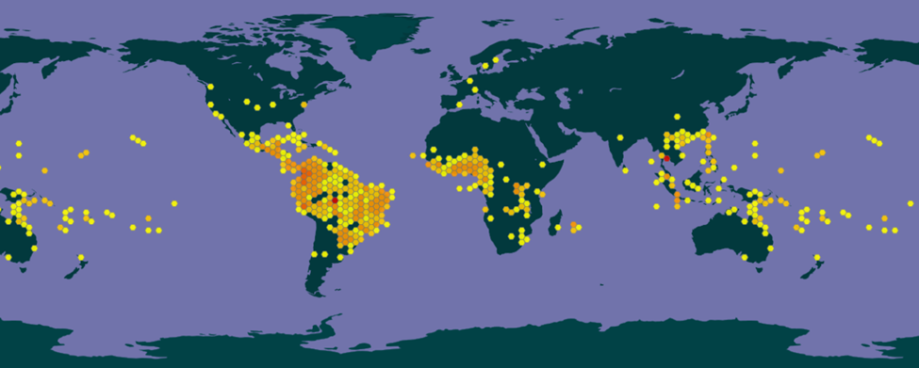

Fig 1. Georeference records of *Manihot esculenta* in present day.

1. **Methodology**

Species occurrence data was collected from GBIF database and then being converted into csv file. The climate data variables was downloaded from worldclim.org at 5 minutes resolution in Generic Grid format. The future climatic conditions also being downloaded in the year of 2050 and through rcp45 column, the bi variables is selected. The obtained data then being processed in RStudio program. Several variables were excluded from the distribution model in order to take out high correlations (correlations > 0.7) within each other. Four bioclimatic variables out of nineteen are chosen that independently affected the models. The chosen variables are BIO1 (Annual Mean Temperature), BIO2 (Mean Diurnal Range), BIO13 (Precipitation of Wettest Month), and BIO15 (Precipitation Seasonality). Species Distribution Models was created by MAXENT Application with bioclimatic variables are taken into account. In running MAXENT, the samples that were used are derived from *Manihot esculenta* GBIF data. The environmental layers are the chosen bioclimatic variables and the present and future climate data was imported as projection layers. The settings that were applied while running MAXENT are as follows: Linear features, Quadratic features, create response curves, and make picture of predictions.

1. **Model Output**

The output model of *Manihot esculenta* for present times and future scenarios resulted from selected variables are shown below. The respective figures doesn’t show any difference in habitat suitability of *Manihot esculenta* in present times and in the year of 2050.

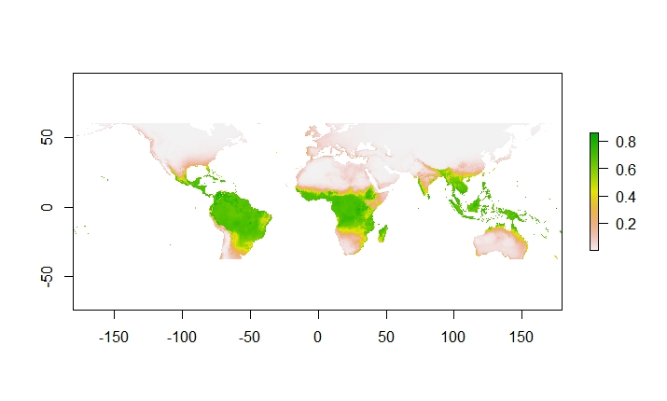

Figure 2. Distribution of *Manihot esculenta* in present conditions

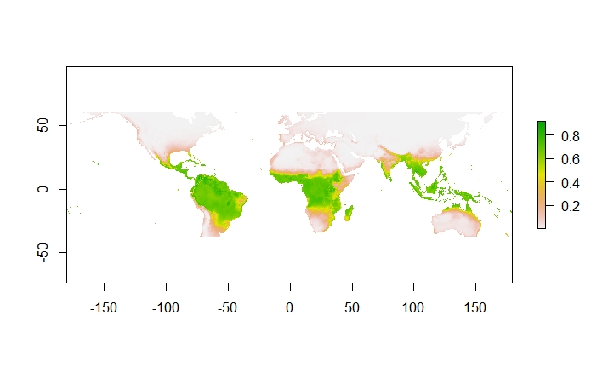

Figure 3. Distribution *Manihot esculenta* in future scenario.

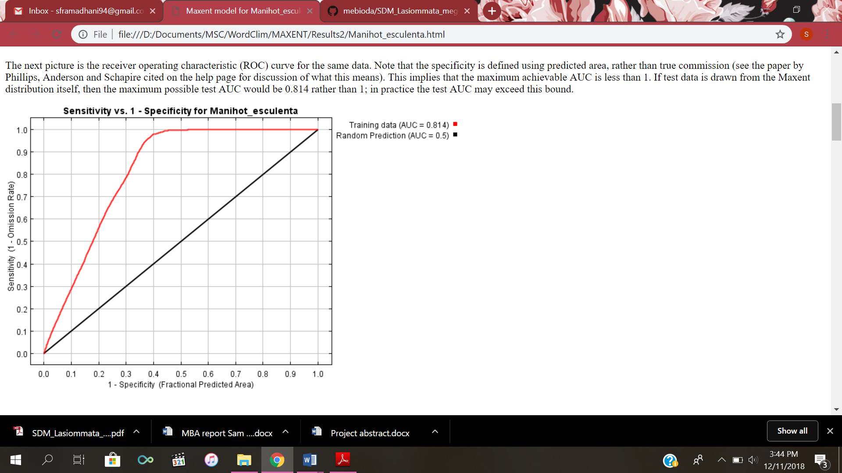

Figure 4. Graph depicting the AUC (Area Under Curve) of the model

The AUC value of the Receiver Operator Curve (ROC) is 0.817, this means that the model is a good model because the value it’s > 0.8. From the MAXENT it is also acquired the logistic threshold of maximum training sensitivity plus specify that is 0.287.

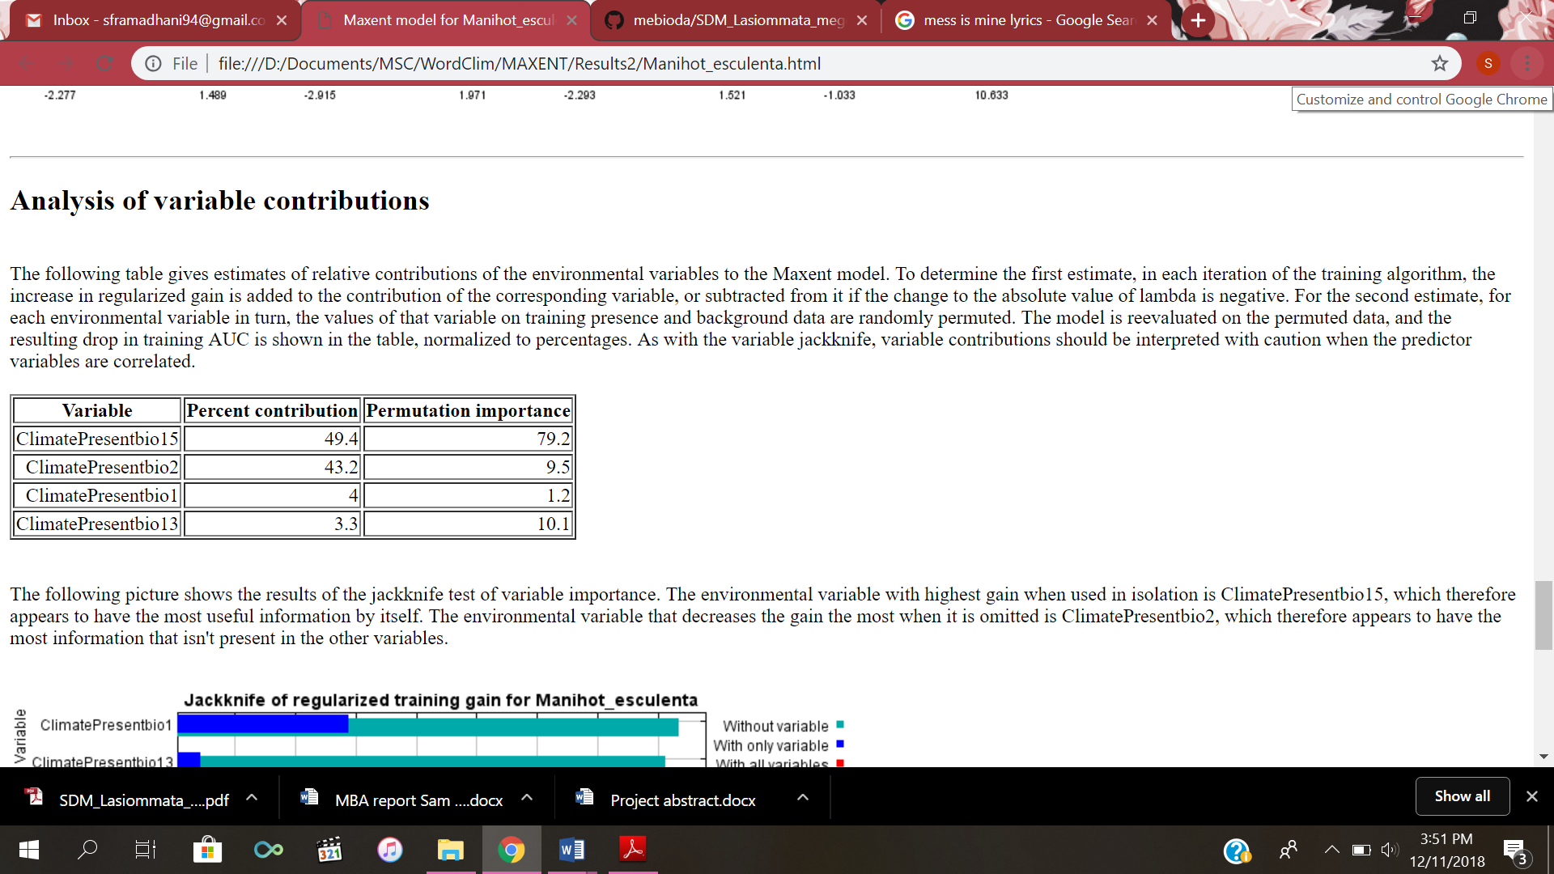

Fig 5. Analysis of importance variable percentages to the model

As shown from the table above, the two most contributed to the model is Precipitation seasonality (Bio15) and Mean Diurnal Range (Bio2).

1. **Response to Future Scenario**

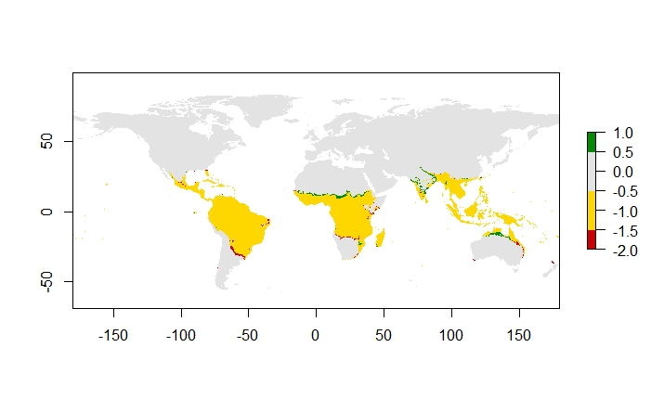

Fig 6. Suitable habitat in the future for *Manihot esculenta* according to climatic condition. Grey areas are never suitable, yellow areas remain suitable, red indicates where suitable habitat is lost and green indicates where suitable habitat is gained.

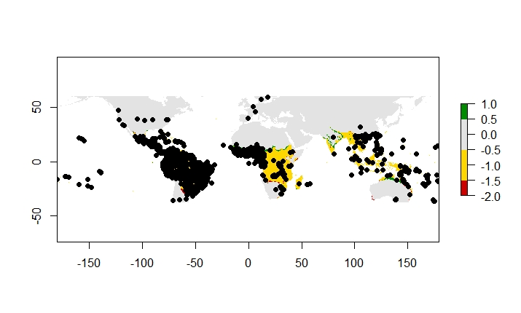

Fig 7. Suitable habitat plot of *Manihot esculenta* under in the future climatic condition

1. **Biological Interpretation**

Based on this model, there are no significance difference in visual representation on global climatic condition in the future (Figure 2 and 3). In closer look, minimum changes are indicated in that area. The shifting habitat suitability also doesn’t show enough alteration in future projection of this species. From Figure 6 and 7, the plots looks scattered and overlapped in the future projections and *Manihot esculenta* still can survive after climate change. This could be because the chosen variables gave indistinct results about the climatic condition in future scheme of the model. Another reason is because the characteristic of the species itself that resilient in drought condition even though the Seasonal Precipitation and Mean Diurnal Range have paid important role in the model. Noticing that *Manihot esculenta* couldn’t grow well with low temperature, it is most likely the occurrence in the temperate zone like Europe could might have different case in the future and this species certainly can’t grow in Norway or in further northern hemisphere as shown in the model.

There’s more than 89 thousands occurrences of *Manihot esculenta* in present times according to GBIF but from the data and there might be not sufficient information about the coordinates. This unclear data points might also affected the model. The input queries from GBIF could be more specified to asses this species based on different variants because this plant is highly cultivated. The status of this species as major food source in some tropical and subtropical countries might resulting in massive occurrence data. Overall, this model is a good model but not really useful for giving insight about future projections of *Manihot esculenta* and still need to be run again with different bioclimatic variables with taking biotic interactions into account.

1. **Reference**

Guillaume Léotard, Anne Duputié, Finn Kjellberg a, Emmanuel J.P. Douzery b, Chantal Debain. Jean-Jacques de Granville , Doyle McKey. 2009. *Phylogeography and the origin of cassava: New insights from the northern rim of the Amazonian basin.* Molecular Phylogenetics and Evolution. 53 (2009) 329–334

Tindall. H. D. 1983. *Vegetables in the Tropics*. MacMillan, Oxford. ISBN 0-333-24268-8